**Lights for Liberty - Social Media Toolkit**

Lights for Liberty: A Nationwide Vigil to End Human Detention Camps now has events scheduled on five continents and in nearly 700 locations worldwide for this Friday night from 7 pm to 9 pm local time.

Beginning at 7 pm on July 12th, advocates, activists, and impacted persons will speak on the issue of detention camps and immigration rights in the United States. At 9 pm or sundown, around the country and around the world, participants will light candles in a silent vigil for all those held in US detention camps to shine a light on the Trump administration’s horrific policies.

In the three weeks since Lights for Liberty was announced, our aim has been to partner with, center on, and amplify all those impacted by and all those who are front-line advocates for those in US detention camps. Our host organizations are all small immigration rights organizations that work every day, and have been working for years, with those who are directly impacted by this administration’s racist immigration and detention policies.

Lights for Liberty is intended to have an impact that sustains far beyond July 12th. Our aim is for participants and sponsoring organizations to build relationships that help amplify and fund their work, and for attendees to come away with specific calls to action and the knowledge and motivation to carry them out.

**TABLE OF CONTENTS**

[Important Links](https://docs.google.com/document/d/11hlNfHDHiLUUh2nG2n3FUD0n5hnxUaoHla2ujRPdX9w/edit#bookmark=id.bousr26wo69)

[Social Media](https://docs.google.com/document/d/11hlNfHDHiLUUh2nG2n3FUD0n5hnxUaoHla2ujRPdX9w/edit#bookmark=id.hciko64tdq29)

[Videos & Images](https://docs.google.com/document/d/11hlNfHDHiLUUh2nG2n3FUD0n5hnxUaoHla2ujRPdX9w/edit#bookmark=id.6r6z312i0d3p)

[DC Logos](https://docs.google.com/document/d/11hlNfHDHiLUUh2nG2n3FUD0n5hnxUaoHla2ujRPdX9w/edit#bookmark=id.y9zdr9572g6l)

**IMPORTANT LINKS**

* Website: <https://www.lightsforliberty.org/>
* Launch video: <http://bit.ly/L4Lvid>
* Endorsement video from Dolores Huerta: <https://bit.ly/2JseV4c>
* Most recent press release: <https://www.prweb.com/releases/lights_for_liberty_approaches_600_events_worldwide_seiu_american_federation_of_teachers_150_others_are_sponsors/prweb16424731.htm>

* NYC (Foley Square) event: <https://www.facebook.com/events/353371105367972/>
* DC event:

<https://www.facebook.com/events/660338147748249/>

* Homestead event: <https://www.facebook.com/events/347447646155278/>
* El Paso event: <https://www.facebook.com/events/376032153043732/>
* San Diego event: <https://www.facebook.com/events/460482731450280/>

**SOCIAL MEDIA**

**Lights for Liberty Social Media Handles:**

Twitter, Facebook, & Instagram all use: @Lights4Liberty

**Hashtags:**

#Lights4Liberty

#EndUSConcentrationCamps

#DontLookAway

**Sample Tweets:** Find videos & images to attach [here](https://docs.google.com/document/d/11hlNfHDHiLUUh2nG2n3FUD0n5hnxUaoHla2ujRPdX9w/edit#bookmark=id.6r6z312i0d3p).

**#1**

*We are proud to be a sponsor of @Lights4Liberty: A Nationwide Vigil to End Human Detention Camps. Join us on July 12th. #DontLookAway #EndUSConcentrationCamps*

*Details & RSVP: [link to FB event]*

**#2**

*We’re sponsoring @LightsforLiberty because we must all work together to #EndUSConcentrationCamps. Join us July 12th. Speakers include [name/s].*

*#DontLookAway*

*Details & RSVP: [link to FB event]*

**#3**

*No person should be in detention for crossing our borders. Not children or parents, toddlers or adults, asylum seekers or undocumented people. No one. Join us on July 12th @Lights4Liberty. [link to FB event]*

**#4**

*This government must stop criminalizing migration, and the desire for safety, work, and a better life. Join us on July 12th @Lights4Liberty.*

*#EndUSConcentrationCamps #DontLookAway [link to FB event]*

**#5**

*.@Lights4Liberty is not about one lone day of action. It’s a chance to elevate orgs that’ve been doing this work for years, to get involved, to demand change AND to fight for it. Join us. [link to FB event]*   
  
**#6**

*Children. Kept in #ConcentrationCamps*

*Children. Ripped from the arms of their parents*

*Children. As young as 2 months old*

*WHAT WILL YOU DO?*

*TODAY #Lights4Liberty vigil*

*TOMORROW Donate to [sponsor org]*

*AFTER THAT: Join a campaign & keep fighting*

#DontLookAway

**Sample Facebook Posts:**

**#1**

Share event listing. Add text such as:

It’s time to fight back, en masse. On July 12th, thousands of people worldwide will attend over 750 [Lights for Liberty](https://www.facebook.com/lights4liberty/) events to send a message: We will not accept concentration camps in the United States. We will not accept the detention of people seeking safety, work, and a better life. We will not accept family separation. And we will not stop fighting until U.S. immigration policies respect the humanity of every person who reaches our borders. Join us.

**#2**

Share event listing. Add text such as:

We are excited to announce that [person/s] will be speaking at Lights for Liberty this Friday. Join us on July 12th to fight back against inhumane detention camps, family separation, cruel & racist immigration policies.

**VIDEOS & IMAGES**

**Videos**

1-minute video [download](https://vimeo.com/tgstudios/download/343764087/74befbc77d)

1-minute video YouTube link: <http://bit.ly/L4Lvid>

Dolores Huerta endorsement Facebook link: <https://www.facebook.com/lights4liberty/videos/2421342291242646/>

**Images**

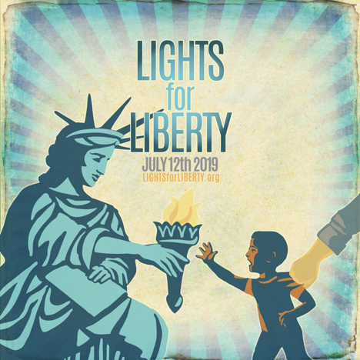





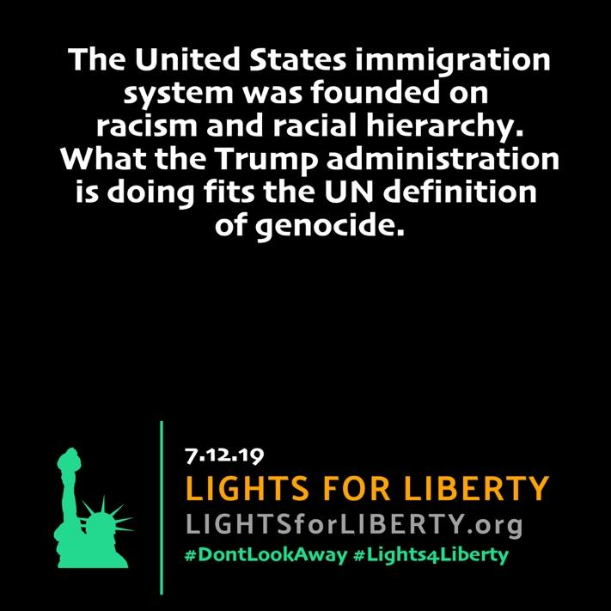

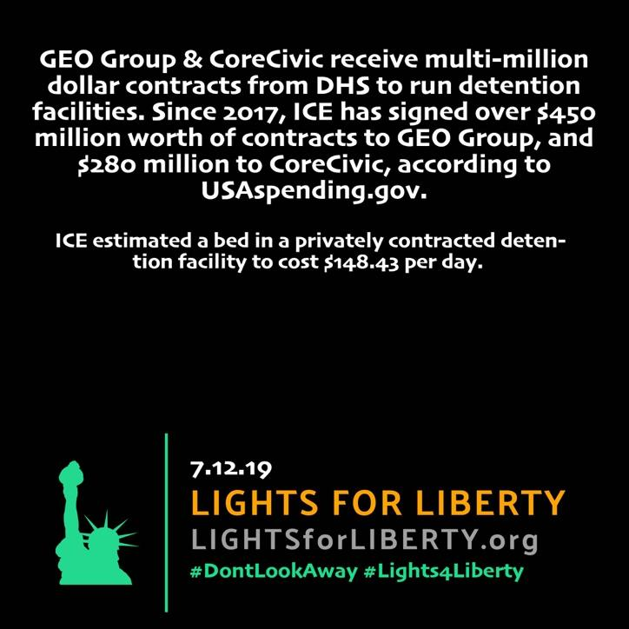

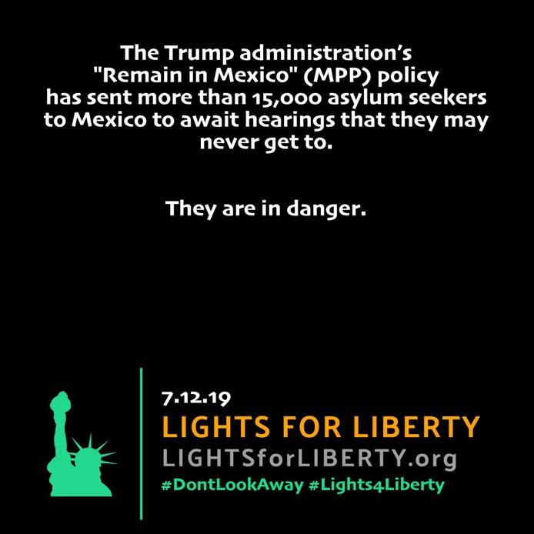

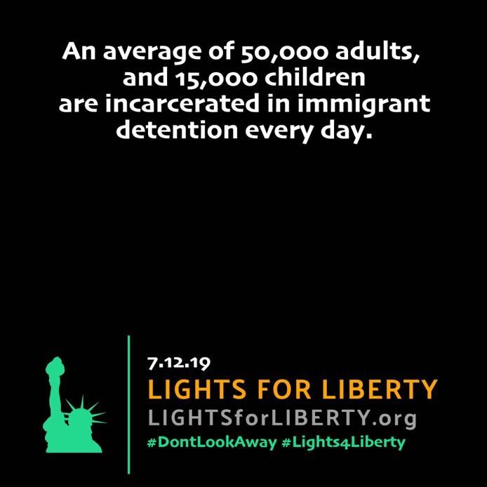

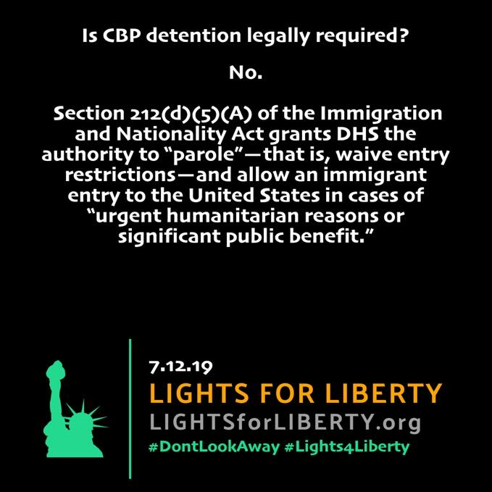

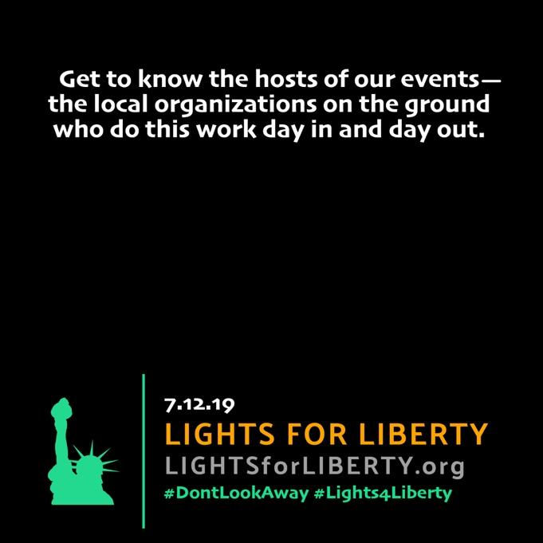

Demands

(please use or incorporate into demands of your local event)

We believe in the rights and freedoms of all to pursue a better life.

We believe that everyone has the right to live, to work and to prosper.

We recognize that it is the desire for work and for safety that drives immigrants to the United States.

We recognize that seeking aslyum is a universal human right.

We demand an end to the criminalization of migrants.

We demand the recognition that every migrant is as human, as worthy, and as important to the fabric of society as any US citizen.

We demand the abolition of family detention, family separation, and all US detention camps.

We demand the abolition of the imprisonment of migrants.

We demand the abolition of the deadly “Remain in Mexico” program, and of all migrant persecution protocols.

We demand the abolition of deportation, and a return of those already deported to the United States at the government’s expense.

We demand family reunification for every migrant child separated from a family member or guardian.

We demand an end to double jeopardy for migrants - a repeal of the 1996 IIRIRA laws that punish migrants twice for the same crime.

We demand recognition that the US immigration system is built upon racism and rooted in the belief in racial hierarchy. We demand an end to the complicity between the immigration and criminal justice systems that deprive black and brown people of dignity and freedom.

We recognize that climate change is a driving force behind regional and international displacement, that the consequences of climate change are extremely serious for refugees and other people of concern, and that climate change will be a driving force behind migration in the coming years.

We demand the passage of the Green New Deal.

We demand an end to any laws or de facto policies that prevent people from entering the United States on the basis of race or religion.

We condemn the discriminatory treatment of LGBTQ and disabled migrants in US detention camps, including by placing LGBTQ and disabled migrants in solitary confinement or in isolation areas. We demand that every migrant be treated with dignity, equity, and respect, and receive medical services as needed.

We demand recognition of the gender identity of transgender migrants, that they not be misgendered in any immigration facility, and that they be provided access to transition-related healthcare as requested.

We demand that the violent, lawless institutions known as Immigration and Customs Enforcement (ICE) and Customs and Border Protection (CBP) be abolished.

We demand mandatory cultural and racial sensitivity training for any US official assigned to any aspect of US immigration policy enforcement.

We demand mass, public, televised trials to hold every government officer and official in the chain of command of the Trump administration, or any private actor, accountable for crimes against humanity as perpetrated at the border and in US immigration detention camps, whether by ICE, CBP, or a private company running any such detention facility.

We demand #NotOneMoreDollar for the Department of Homeland Security until all those responsible for atrocities in US detention camps are held accountable, every detention camp is closed, and all those seeking asylum are freed.

We demand no pardons for any person engaged in or responsible for the atrocities that are currently ongoing at the border and in US detention camps.

We demand that the US become a signatory to the United Nations’ Universal Declaration of Human Rights.

We demand the creation of a Victims Compensation Fund, similar to that created for 9/11 victims, administered by an outside mediator, for all those who have been victimized by and in US immigration detention camps.

We demand the complete end to all forms of immigration detention, and we will be here for as long as it takes, until the United States lives fully and completely into the principles of freedom, dignity, equity and respect for all, and the principle of do no harm.

**Calls to Action for Participants**

1. **Donate** to a local host organization in your area that is doing frontline support work for migrants and those in detention. Make it a monthly donation if you can.
2. **Call** your US representative and senators **daily** and demand an end to US concentration camps, accountability for DHS, ICE and CBP, and an end to human detention for all migrants.
3. **Volunteer** with a local immigration rights advocacy organization. [Our host organizations](https://www.lightsforliberty.org/sponsors) are a good place to start.
4. **Activate** within your community by organizing with your neighbors, your friends, and your colleagues for ongoing action against detention camps in your area.
5. **Engage in non-violent civil disobedience** for as long as it takes to close every detention camp. Organize local protests, sit-down strikes, and ongoing action at ICE, CBP and local representative offices, and local detention camps, and support those who do with money, amplification on social media, media access and coverage, and your time. We can provide networks and resources to support these efforts.